FACULTY OF ENGINEERING AND NATURAL SCIENCES

DEPARTMENT OF COMPUTER ENGINEERING



MATCHMAKER

SOFTWARE DEVELOPEMNT REPORT

A GRADUATION PROJECT

SUBMITTED BY

GOKTURK RAMAZAN DOGAN

BACHELOR OF SCIENCE

JUNE 2022

PROGRAM: COMPUTER ENGINEERING

MATCHMAKER

A GRADUATION PROJECT

BY

GOKTURK RAMAZAN DOGAN

SUBMITTED TO THE DEPARTMENT OF COMPUTER ENGINEERING OF

OKAN UNIVERSITY

BACHELOR OF SCIENCE

Approved by:

|  |  |  |
| --- | --- | --- |
|  |  |  |
| Member’s  Name |  | Member’s  Name |
| Member’s  Name |  | Member’s  Name |
|  |  |  |
|  |  |  |

JUNE 2022

Program: COMPUTER ENGINEERING

**ABSTRACT**

MATCHMAKER

This project has two main objectives, the first of which is the problem of finding players in football match organizations, and the other is the lack of competition due to the fact that the established teams are not of equal strength. It provides the manager with the opportunity to create a player pool from the players whose information he/she will enter into the system, and gives the authority to give a score out of five to the players who take charge after the matches. In this way, both the player problem and the competition problem are solved.

Keywords:

* Football
* Team
* Player
* Facility
* Match
* Goal
* Point
* Vote
* Algorithm
* Goalkeeper
* Defence
* Midfielder
* Forward

**CONTENTS**

LIST OF TABLES V

LIST OF FIGURES VI

1. INTRODUCTION 1

1.1. Title 1

1.2. Project Definition 1

2. SOFTWARE REQUIREMENT SPECIFICATION 1

2.1. Introductıon 1

2.2. General Descrıptıon 1

2.3. Pıcture Of System Data flow 2

2.4. Data To be Stored 3

2.5. Functıonal requırements 4

2.6. Functıonal Behavıors 5

2.7. System Specıfıcatıon 9

2.8. Non-Functıonal Attrıbutes 10

2.9. Valıdatıon Creterıa 10

2.10. Functıon Poınt Analys 10

3. software desıgn descrıptıon 14

3.1. Introductıon 14

3.2. Data Desıgn 14

3.3. Module Structure 19

3.4. Interface Desıgn 31

3.5. Recommendatıon 42

4. test plan and test report 42

4.1. Addıng Player 42

4.2. Addıng facility 43

4.3. Addıng match 44

5. dıscussıon and conclusıon 46

5.1. Succesfull Aspects 46

5.2. Sefıcıencıes 46

5.1. Succestıons 46

source 47

cv 48

**LIST OF TABLES**

Table 1 11

Table 2 12

Table 3 12

Table 4 13

Table 5 13

Table 6 15

Table 7 16

Table 8 16

Table 9 18

Table 10 18

Table 11 18

Table 12 19

**LIST OF FIGURES**

Figure 1 2

Figure 2 3

Figure 3 5

Figure 4 15

Figure 5 19

Figure 6 21

Figure 7 22

Figure 8 23

Figure 9 24

Figure 10 25

Figure 11 26

Figure 12 27

Figure 13 28

Figure 14 29

Figure 15 30

Figure 16-17 31

Figure 18-19 32

Figure 20-21 33

Figure 22-23 34

Figure 24-25 35

Figure 26 36

Figure 27-28 37

Figure 29-30-31-32 38

Figure 33-34-35 39

Figure 36-37-38 40

Figure 39-40-41 41

Figure 42 42

Figure 42-44 43

Figure 45-46-47 44

Figure 48 45

1. **INTRODUCTION**
   1. **TITLE**

MatchMaker.

* 1. **PROJECT DEFINITION**

This project has two main objectives, the first of which is the problem of finding players in football match organizations, and the other is the lack of competition due to the fact that the established teams are not of equal strength. It provides the manager with the opportunity to create a player pool from the players whose information he/she will enter into the system, and gives the authority to give a score out of five to the players who take charge after the matches. In this way, both the player problem and the competition problem are solved.

1. **SOFTWARE REQUIREMENTS SPECIFICATION**

# INTRODUCTION

## Purpose of This Report

## This report contains the software contents of the MatchMaker project.

## Scope of This Report

This report describes the functional requirements and behaviour.

# GENERAL DESCRIPTION

# The MatchMaker project is a web-based project focused on the two most basic problems experienced in football competition organizations. The first of these is the problem of finding players. In order to solve this problem, the user who is given the administrator right will be able to create a pool of players by adding the information of the football players around him to the database of the project. The powers of the manager will also include functions such as adding matches within the project and adding potential facilities where the matches will be played. In this way, side problems such as finding a facility and setting a match time will also be addressed. Another basic problem is that the teams formed are not equal to each other and therefore the competition and entertainment level of the competition is insufficient. To solve this problem, the project will include a voting system under the authority of the administrator. In this way, after the matches, the manager will be able to rate the players based on his observations in the match, and thus, while forming a team in the next match, he will be able to see their point match their played latly and create an organization with a higher level of competition by evenly distributing the players with high scores.

## Critical Assumption

In this project, it is assumed that the people who are given the management will have an objective approach while voting. In case of abuse, no responsibility is accepted.

# PICTURE OF SYSTEM, DATA FLOW

There are two types of users registered in our system. One of them is the administrative user, which has the authority to add, delete, vote and edit. Another is anonymous users who are not authorized to interact directly with the project's system and database. Anonymous users are not authorized to access the administration panel and the database, they can only see the interface designed for them and the reflection of the information in the database there. Their purpose is only to obtain information about the data in the system.. Context Diagram of Data Flow Diagram is shown in **Figure 1**.

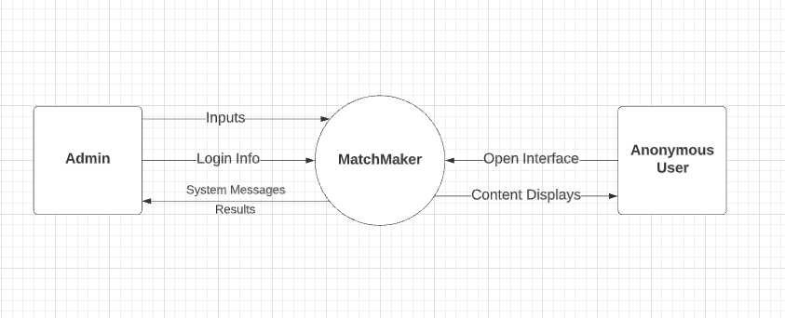

Figure 1.

When we look at the function diagram, the connection between the transactions and the database is shown in **Figure 2.** All inputs are taken from the administrator and forwarded to the database.

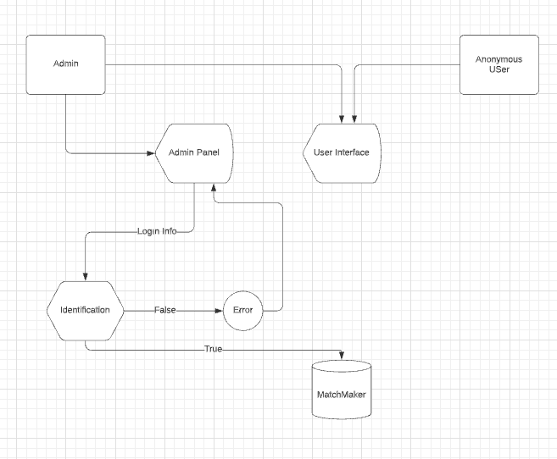

Figure 2.

# DATA TO BE STORED

1. As stated in Chapter 2, this database will store data about players, matchers and facilities. Theese informations are football-related data such as the player's contact information, age, profile photo required for profile creation, the foot and position used by the player. For matches theese are teams, date and time. For facilities theese are location, phone number, facility name, field kind and field count.
2. In addition, in order for the system to fulfill its requirements, another type of information that the players must keep apart from their information is the information that will enable the user or users to perform the login function, such as the user name and password of the user or users who are given administrative authority.

# FUNCTIONAL REQUIREMENTS

## Functional Partitioning

The software of the project includes four different functions. All of these functions are available to the user with administrative authority. These are Add Player, Add Match, Add Facility, Edit Content, Delete Content and Vote.

## 2.5.2. Add Player

The user, who is given the administrator ID, can enter the information of the players he wants to add to the system through the inputs on the relevant page. The system will create a new row in the players table and save the data entered in the relevant columns.

## Add Match

This function allows the user to create a match by selecting its date, time and facility and then add teams to that match via the required pages.

## Add Facility

Through this function, the administrator user can enter the facilities where future matches will be organized into the system and ensure that they are recorded in the relevant table.

## Edit Content

This function allows the admin user to update or edit the contents of data such as previously logged facilities and players. If it is used, it completes the editing process through the relevant inputs by calling the exact same insertion pages.

## Delete Content

If the administrator decides to delete the previously entered content, he or she can go to the list page of the relevant content and click the button that enables the function to be deleted, thanks to this function.

## Add Team

The administrator can add players in two teams to the matches via this function.

## Vote

This function, which enables the manager to vote for the players who took part in the organized competition after the organized competitions, will only be accessible to the manager users.

# FUNCTIONAL BEHAVIORS

## Events, Actions and User Interface

In this section, the response of the program to all possible inputs and actions of the users as well as user interfaces will be described. The overall process flowchart is

shown in **Figure 3**.

The screens that the user can perform actions are listed below

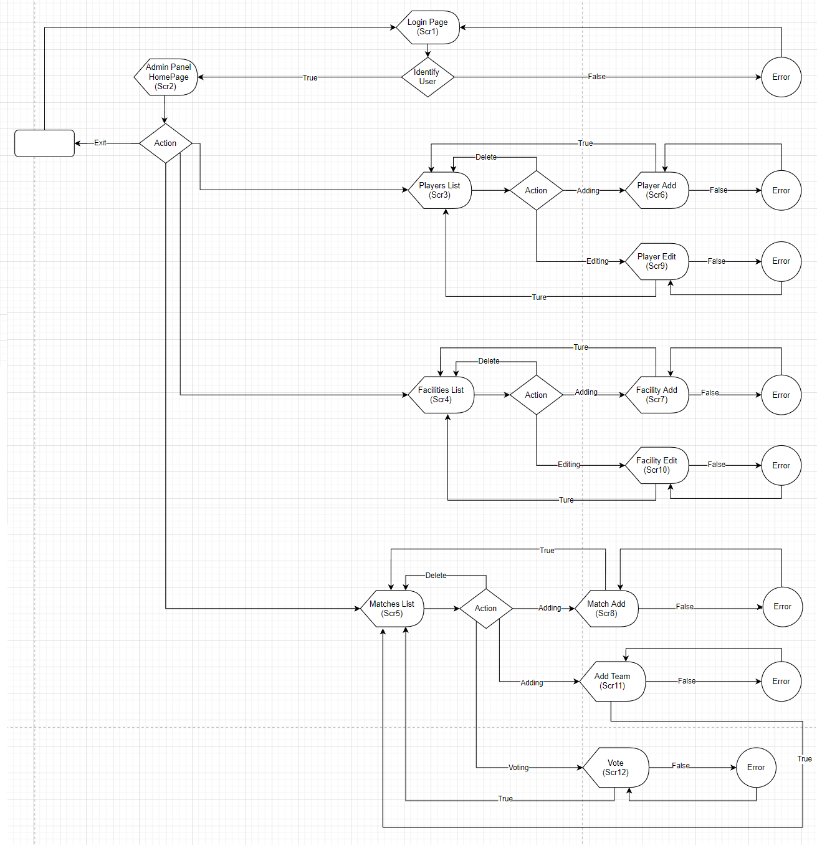

Figure 3.

### **2.6.1.1** **Login Screen (Scr 1)**

If the administration panel is opened, the user will first be greeted by a login form with two inputs, where user name and password entry will be provided.

1. If the login information entered by the user matches the data previously stored in the relevant table in the database, it will direct the user to the homepage of the Administration Panel (Scr 2).
2. If the login information entered by the user does not match the data in the table, a warning will appear that the information entered is incorrect and the user will be redirected to the login page (Src 1).

### **2.6.1.2 Admin Panel Home Page(Scr 2)**

On this screen of the system, the administrative user is directed to the module adding page that creates a new category, to the list page that displays the contents of the previously created categories, and to the add, delete and edit pages via the list page.

1. By clicking on the name of the category for which the admin user wants to add, edit or delete content, the user can be directed to the page where the contents of the relevant category are listed.
2. The administrator can log out from the administration panel by clicking the ’Çıkış Yap’ button at the bottom of the menu bar. As a result of this action, it is directed to the login page (Src 1) again.

### **2.6.1.3 Admin Panel ‘Oyuncular’ List Screen(Scr 3)**

On this page of the administration panel, the administrator can view all the players in the category to be listed, together with the preview data.

1. Admin by clicking the ‘Yeni ekle’ button. can go to the relevant page (Scr6) to add a new player.
2. Admin can access the relevant edit page (Scr9) to edit the data of the relevant player by clicking the ‘Düzenle’ button.
3. To delete the player, the administrator user can delete the relevant player from the table in the database by clicking the ‘Kaldır’ button opposite the player. As a result, the administrator will be redirected to the relevant players list page (Scr 3) again.

### **2.6.1.4 Admin Panel ‘Tesisler’ List Screen(Scr 4)**

On this page of the administration panel, the administrator can view all the facilities in the category to be listed, together with the preview data.

1. Admin by clicking the ‘Yeni ekle’ button. can go to the relevant page (Scr7) to add a new facility.
2. Admin can access the relevant edit page (Scr10) to edit the data of the relevant facility by clicking the ‘Düzenle’ button.
3. To delete the facility, the administrator user can delete the relevant facility from the table in the database by clicking the ‘Kaldır’ button opposite the facility. As a result, the administrator will be redirected to the relevant facility list page (Scr 4) again.

### **2.6.1.5 Admin Panel ‘Maçlar’ List Screen(Scr 5)**

On this page of the administration panel, the administrator can view all the matches in the category to be listed, together with the preview data.

1. Admin by clicking the ‘Yeni ekle’ button. can go to the relevant page (Scr8) to add a new match.
2. The administrator can switch to the add team page (Scr11) to the relevant match by clicking the ‘Takım A / Takım B’ buttons.
3. By clicking the ‘Oyla’ button, the administrator can switch to the voting page (Scr12) of the relevant match and give points to the players who took part in the match and can enter the scores produced by the teams.
4. To delete the content, the administrator user can delete the relevant content from the table in the database by clicking the ‘Kaldır’ button opposite the match. As a result, the administrator will be redirected to the relevant list page (Src 5) again.

### **2.6.1.6 Admin ‘Oyuncular’ Adding Screen(Scr 6)**

On this page, the administrator can enter new players into the system. The administrator cannot leave the inputs in the page blank due to the algorithm in which the function is written. These inputs are name, surname, location, phone number, picture, year of birth and the foot he used, respectively. As a result of the process, the user will be redirected to the players list (Src 3) page.

### **2.6.1.7 Admin ‘Tesisler’ Adding Screen(Scr 7)**

On this page, the administrator can enter new facilities into the system. The administrator cannot leave the inputs in the page blank due to the algorithm in which the function is written. These inputs are facility name, address, site type, phone number, picture, and location, respectively. As a result of the process, the user will be redirected to the facility list (Src4) page.

### **2.6.1.8 Admin ‘Maçlar’ Adding Screen(Scr 8)**

On this page, the administrator can enter new matches into the system. The administrator cannot leave the inputs in the page blank due to the algorithm in which the function is written. These inputs are date, address, time and facility, respectively. As a result of the process, the user will be redirected to the matches list (Src5) page.

### **2.6.1.9 Admin Panel Edit ‘Oyuncular’ Screen(Scr 9)**

On this page of the user administration panel, the administrator can edit the data of the relevant player and save it back to the database in an updated way. As a result of this process, it will be redirected to the player list page (Src 3).

### **2.6.1.10 Admin Panel Edit ‘Tesisler’ Screen(Scr 10)**

On this page of the user administration panel, the administrator can edit the data of the relevant facility and save it back to the database in an updated way. As a result of this process, it will be redirected to the facility list (Src 4) again.

### **2.6.1.11 Admin Panel ‘Maçlar’ Add Team Screen(Scr 11)**

On this page, the administrator can add players in two teams to the matches and ensure that the data is transmitted to the table where the records of the matches are kept. As a result of this process, it will be redirected to the match list page (Src 5) again.

### **2.6.1.12 Admin Panel ‘Maçlar’ Vote Screen(Scr 12)**

On this page, the administrator can give points out of 5 to the players who took part in a match that has been added and played before, and can save the scores produced by the teams to the system via inputs. As a result of this process, it will be redirected to the match list page (Src 5) again.

# SYSTEM SPECIFICATION

## Client

Although the MatchMaker project is a web-based project. It is recommended to run it in an HTML 5.0 and CSS 3.0 compatible browser. The project does not have any system requirements. For this reason, any device that has an internet connection and supports browser services can access this project without hardware barriers.

## Server

The server to which the project is linked will be kept on the internet, so it is recommended that the users who will access it have a stable internet connection.

### **Required Software**

The server is built on apache server with xampp control panel 3.4 version support. It works with phpMyAdmin version 4.2.

### **Required Hardware**

There is no hardware requirement as the database information will be stored on the internet. 100mb of space on the relevant host will be sufficient.

# NON-FUNCTIONAL ATTRIBUTES

## Security

### **System Security**

Database access will be provided only with the username and password to be created by the relevant host, and this information will only be given to administrative users. The default security practices of the phpMyAdmin system will remain in effect.

### **Network Security**

This system, which will work in a local or global network environment, will host a .htaccess application with linking, so it will not receive any attack from the link input. The SSL certificate can then be applied to the site over the host.

### **User Security**

Panel logins are made with user names and passwords. Each administrator ID has its own unique user name and password. It is the responsibility of the administrators to keep them confidential.

# VALIDATION CRITERIA

Experts Database Software Development Project can be considered to be complete when the following conditions hold:

1. All functional requirements specified in Section 4 are met.
2. All user interfaces that are specified in Section 5 are complete.
3. The program responses to inputs described in Section 5 are as specified.

# FUNCTION POINT ANALYSIS

## Total Unadjusted Function Point Calculation

**External Inputs**

1. Login Screen **Simple**
2. HomePage **Simple**
3. List Screens **Average**
4. Edit Screens **Simple**
5. Adding Screens **Simple**
6. Vote Screen **Average**

**External Outputs**

1. HomePage **Simple**
2. List Screens **Average**

**File Storage**

1. Information Database **Complex**

**External SW Interfaces**

1. Data transfer interface between web browser and database **Complex**

##### External Query Types

1. Vote **Complex**

|  |  |  |  |  |
| --- | --- | --- | --- | --- |
|  | Weighting Factor | | |  |
| **Measurement Parameter** | **Simple** | **Average** | **Complex** | **Total** |
| External Inputs | **4**\*4= | **2**\*4= | **0**\*6= | **24** |
| External Outputs | **1**\*4= | **1**\*5= | **0**\*7= | **9** |
| File Storage | **0**\*7= | **0**\*10= | **1**\*15= | **15** |
| External SW Interfaces | **0**\*5= | **0**\*7= | **1**\*10= | **10** |
| Count Total | | | | **68** |

## Table 1.

## Adjusted Function Point Calculation

The function point count is adjusted for the complexity of the software by assessing each of the answers to the following questions on a scale of 0 to 5.

|  |  |
| --- | --- |
|  | **Fi value** |
| None | 0 |
| Slightly | 1 |
| Present | 2 |
| Medium level | 3 |
| Important | 4 |
| Vital | 5 |

Table 2.

|  |  |  |
| --- | --- | --- |
| 1. Data Communications | Vital | **5** |
| 2. Distributed Processing | None | **0** |
| 3. Performance Requirements | Important | **4** |
| 4. Operational Configuration Load | None | **0** |
| 5. Transaction Rate | Medium level | **3** |
| 6. Online Data Input | Medium level | **3** |
| 7. End User Quality | None | **0** |
| 8. Online File Update | Important | **4** |
| 9. Algorithmic Complexity | Slightly | **1** |
| 10. Reusability | None | **0** |
| 11. Ease of Installation | Slightly | **1** |
| 12. Operational Ease | Slightly | **1** |
| 13. Multi-site System | None | **0** |
| 14. Maintainability | Medium level | **3** |
|  | TOTAL | **25** |

Table 3.

These 14 complexity adjustment values are summed to give the value of Σ (*Fi*).

**Σ (*Fi*) = 25**

**Adjusted Function points** = Count Total * (0.65 + 0.01 * Σ (*Fi*))

=64*0.9 = **58.5.**

## Lines of Code Estimation

The total adjusted function points came out to be 45.9 for the Experts’ Database. For estimating lines of code we can use the **Table 1** below.

|  |  |  |
| --- | --- | --- |
| Language | (Albrecht 1983) | (Low & Jeffery 1990) |
| COBOL | 110 LOC / FP | 106 LOC / FP |
| PL / 1 | 65 LOC / FP | 80 LOC / FP |
| 4 GL | 25 LOC / FP | 40 LOC /FP |

Table 4.

Estimated LOC for each FP.

|  |  |  |
| --- | --- | --- |
| Language | LOC(Albrecht 1983) | LOC(Low & Jeffery 1990) |
| COBOL | **58.5**\*110=6435 | **58.5**\*106=6201 |
| PL / 1 | **58.5**\*65=3803 | **58.5**\*80=4680 |
| **4 GL** | **58.5*25=1463** | **58.5*40=2340** |

Table 5.

LOC calculation.

For 4GL, the results are came up to be **1463 LOC** according to Albrecht 1983 and **2340 LOC** according to Low & Jeffery 1990.

**3.  SOFTWARE DESIGN DESCRIPTION**

# 3.1. INTRODUCTION

## 3.1.1. Project Name:

MatchMaker.

## 

## 3.1.2. Purpose of This Report:

This report contains information about the software design features and developability of the MatchMaker project.

## 

## 3.1.3. View of The Report:

Data structure, module structure, administration panel admin interface and user interface designs are presented in this report. It must be used together with the requirements specification report.

## 

## 3.1.4. Abbreviations and synonyms used:

**Admin:** Administrator.

**Info:** Information.

**Int:** User Interface.

**UserID:** User identification.

# 3.2. DATA DESIGN

## 3.2.1. Data Objects and Resultant Data Structures

The entity-relationship diagram of the MatchMaker is depicted in the below figure. The Matchmaker system has two data objects. one of them is the administrator data object and one is the login data object. The login data object contains the username and password information. If the entered data matches the data in the database, the login operation is successful. If it does not match, the login will fail.

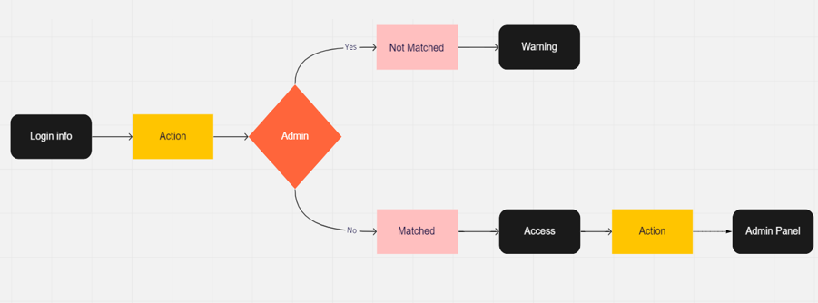

Figure 4.

Login Event MatchMaker

Based on the E-R model, following tables are created. The fields of tables, the type nad primary key. All of them has created by admin manually from the database.

|  |  |  |  |
| --- | --- | --- | --- |
| **Fields** | Type | **Primary Key / Foreign Key** | Required |
| **ayarlar** |  |  |  |
| ID | Int(11) | Primary Key |  |
| baslik | Varchar(160) |  | √ |
| anahtar | Varchar(255) |  | √ |
| aciklama | Varchar(255) |  | √ |
| telefon | Varchar(50) |  | √ |
| mail | Varchar(100) |  | √ |
| adres | Varchar(255) |  | √ |
| fax | Varchar(50) |  | √ |
| url | Varchar(120) |  | √ |

Table 6.

|  |  |  |  |
| --- | --- | --- | --- |
| **Fields** | Type | **Primary Key / Foreign Key** | Required |
| **kullanicilar** |  |  |  |
| ID | Int(9) | Primary key |  |
| adsoyad | Varchar(20) |  | √ |
| kullanici | Varchar(20) |  | √ |
| sifre | Varchar(20) |  | √ |
| mail | Varchar(30) |  | √ |
| tarih | Date |  |  |

Table 7.

|  |  |  |  |
| --- | --- | --- | --- |
| **Fields** | Type | **Primary Key / Foreign Key** | Required |
| **maclar** |  |  |  |
| ID | Int(11) | Primary key |  |
| tarih | Varchar(55) |  | √ |
| saat | Varchar(55) |  | √ |
| tesis | Varchar(120) |  | √ |
| takimakaleci | Varchar(500) |  |  |
| takimadefans1 | Varchar(500) |  |  |
| takimadefans2 | Varchar(500) |  |  |
| takimadefans3 | Varchar(500) |  |  |
| takimaortasaha1 | Varchar(500) |  |  |
| takimaortasaha2 | Varchar(500) |  |  |
| takimaforvet | Varchar(500) |  |  |
| takimbkaleci | Varchar(500) |  |  |
| takimbdefans1 | Varchar(500) |  |  |
| takimbdefans2 | Varchar(500) |  |  |
| takimbdefans3 | Varchar(500) |  |  |
| takimbortasaha1 | Varchar(500) |  |  |
| takimbortasaha2 | Varchar(500) |  |  |
| takimbforvet | Varchar(500) |  |  |
| takimakalecipuan | Int(11) |  |  |
| takimadefans1puan | Int(11) |  |  |
| takimadefans2puan | Int(11) |  |  |
| takimadefans3puan | Int(11) |  |  |
| takimaortasaha1puan | Int(11) |  |  |
| takimaortasaha2puan | Int(11) |  |  |
| takimaforvetpuan | Int(11) |  |  |
| takimbkalecipuan | Int(11) |  |  |
| takimbdefans1puan | Int(11) |  |  |
| takimbdefans2puan | Int(11) |  |  |
| takimbdefans3puan | Int(11) |  |  |
| takimbortasaha1puan | Int(11) |  |  |
| takimbortasaha2puan | Int(11) |  |  |
| takimbforvetpuan | Int(11) |  |  |
| takimaskor | Int(55) |  |  |
| takimbskor | Int(55) |  |  |

Table 8.

|  |  |  |  |
| --- | --- | --- | --- |
| **Fields** | Type | **Primary Key / Foreign Key** | Required |
| **mevki** |  |  |  |
| ID | Int(11) | Primary key |  |
| mevki | Varchar(120) |  | √ |
| url | Varchar(500) |  | √ |

Table 9.

|  |  |  |  |
| --- | --- | --- | --- |
| **Fields** | Type | **Primary Key / Foreign Key** | Required |
| **mevki** |  |  |  |
| ID | Int(11) | Primary key |  |
| isim | Varchar(255) |  | √ |
| soyisim | Varchar(255) |  | √ |
| mevki | Varchar(255) |  | √ |
| telefonnumarasi | Varchar(255) |  | √ |
| ayak | Varchar(255) |  | √ |
| resim | Varchar(500) |  | √ |
| dogumtarihi | Varchar(255) |  | √ |
| mevkiid | Int(11) |  | √ |

Table 10.

|  |  |  |  |
| --- | --- | --- | --- |
| **Fields** | Type | **Primary Key / Foreign Key** | Required |
| **puan** |  |  |  |
| ID | Int(11) | Primary key |  |
| mevki | Varchar(120) |  | √ |
| url | Varchar(500) |  | √ |

Table 11.

|  |  |  |  |
| --- | --- | --- | --- |
| **Fields** | Type | **Primary Key / Foreign Key** | Required |
| **tesisler** |  |  |  |
| ID | Int(11) | Primary key |  |
| tesisadi | Varchar(255) |  | √ |
| sahasayisi | Varchar(255) |  | √ |
| telefon | Varchar(30) |  | √ |
| sahatipi | Varchar(20) |  | √ |
| resim | Varchar(255) |  | √ |
| adres | Varchar(255) |  | √ |
| konum | Varchar(500) |  | √ |

Table 12.

# 3.3. MODULE STRUCTURE(FOR ADMIN PANEL)

## 3.3.1. Module Map:

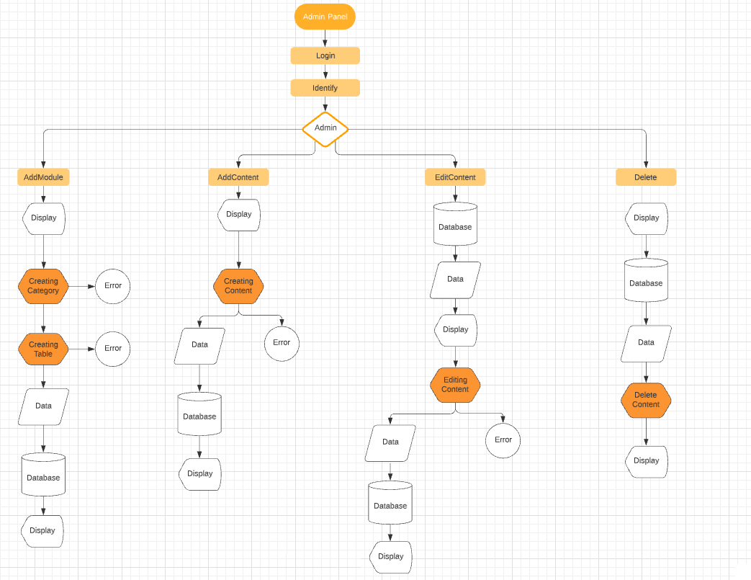

Figure 5.

## Login:

Function : Program entry, gets name and password of the user and passes to Identify module .

Called by : Main program entry, called firstly after running the AdminPanel.

Calls : Identify module.

Inputs : Name and password information from user.

Outputs : Name and password information from user passes to Identify module.

Algorithm : Display Login Page (see Int.1.) shown in part 5-interface design.

Get name and password of user as strings from login form at the page of Login.

Call Identify module.

## 3.3.3. Identify:

Function : Gets name and password of the user (see Int.1.) shown in part 5-interface design. Checks their validity from Admin table from database.

Called by : Login Module.

Calls : Error Module, Admin Panel Homepage.

Inputs : Username and password information.

Outputs : If login is success Refreshes the page and goes to Main page of Admin Panel (see Int. 2.). If it is not, displays (see Int. 6-1-1. or Int. 6-1-2.) shown in part 5-interface design.

Algorithm :

metin içeren bir resim

Açıklama otomatik olarak oluşturuldu

Figure 6.

## 3.3.4. Addplayers:

Function : This module saves the player information entered by the administrator on the relevant form page (see Int. 3-2.) in the 'oyuncular' table. shown in part 5-interface design.

Called by : Identify module.

Calls : Error Module.

Inputs : Information of the player to be created.

Outputs : If the add operation is successful displays (see Int. 6-2-1.) and switches to players-list (see Int. 3-1.). But if the add operation is not successful displays (see Int. 6-3.) shown in part 5-interface design.

Algorithm :

metin içeren bir resim

Açıklama otomatik olarak oluşturuldu

Figure 7.

## 3.3.5. Addfacilities:

Function : This module by taking the information of the facility to be entered from the form on the page (see Int. 4-2.) by admin. records in the corresponding columns in the 'tesisler' table.

Called by : Identify module.

Calls : Editfacilities Module, Delete Module, Error Module.

Inputs : Information of the faicility to be created.

Outputs : If the save operation is successful display (see Int. 6-2-1.) and switches to facility-list page (see Int. 4-1.) in part-5. But if the save is not successful displays (see Int. 6-3.) in part-5.

Algorithm : Display Addfacility page (see Int. 4-2.) in part-5.

metin içeren bir resim

Açıklama otomatik olarak oluşturuldu

Figure 8.

## 3.3.6. Addmatches:

Function : This module saves the match data received by the admin from the form inputs on the match add page to the 'maclar' table.

Called by : Identify module.

Calls : Editmatch Module, Delete Match Module, Error Module, Addteam Module, Vote Module.

Inputs : Information of the match to be created.

Outputs : If the save operation is successful display (see Int. 6-2-1.) and switches to match-list page (see Int. 5-1.) in part-5. But if the save is not successful displays (see Int. 6-3.) in part-5.

Algorithm : Display Addmatches page (see Int. 5-2.) in part-5.

metin içeren bir resim

Açıklama otomatik olarak oluşturuldu

Figure 9.

## 3.3.7. Editplayers:

Function : It allows editing the data of the players added to the related table with the Addplayers algorithm.

Called by : Identify Module, Addplayers Module.

Calls : Error Module, Delete Module.

Inputs : Replacing the data of the relevant player with the data to be updated.

Outputs : It displays (see Int. 6-2-1.) or (see Int. 6-3.) in part-5.

Algorithm : After the editing process is finished displays (see Int. 6-2-1.) if the proccess is success. But if it is not displays (see Int. 6-3.) in part-5.

metin içeren bir resim

Açıklama otomatik olarak oluşturuldu

Figure 10.

## 3.3.8. Editfacilities:

Function : It allows editing the data of the facility added to the related table with the Addfacilities algorithm.

Called by : Identify Module, Addfacilities Module.

Calls : Error Module, Delete Module.

Inputs : Replacing the data of the relevant facility with the data to be updated.

Outputs : It displays (see Int. 6-2-1.) or (see Int. 6-3.) in part-5.

Algorithm : After the editing process is finished displays (see Int. 6-2-1.) if the proccess is success. But if it is not displays (see Int. 6-3.) in part-5.

metin içeren bir resim

Açıklama otomatik olarak oluşturuldu

Figure 11.

## 3.3.9. Addteam:

Function : This module gives the authority to add the players as teams to the positions where they will be assigned by the manager and adds this data to the columns of the relevant match in the 'maclar' table.

Called by : Addmatches Module.

Calls : Error Module, Delete Module, Vote Module.

Inputs : Selection of players from the relevant select inputs by the administrator

Outputs : It displays (see Int. 6-2-1.) or (see Int. 6-3.) in part-5.

Algorithm : After the adding process is finished displays (see Int. 6-2-1.) if the proccess is success. But if it is not displays (see Int. 6-3.) in part-5.

metin içeren bir resim

Açıklama otomatik olarak oluşturuldu

Figure 12.

## 3.3.10. Vote:

Function : This module records the score entered by the administrator and the performance information of the players out of 5 in the relevant columns in the 'maclar' table.

Called by : Addmatches Module, Addteam Module.

Calls : Error Module, Delete Module.

Inputs : The score produced by the teams entered by the manager and the performance score shown by the players.

Outputs : It displays (see Int. 6-2-1.) or (see Int. 6-3.) in part-5.

Algorithm : After the voting process is finished displays (see Int. 6-2-1.) if the proccess is success. But if it is not displays (see Int. 6-3.) in part-5.

metin içeren bir resim

Açıklama otomatik olarak oluşturuldu

Figure 13.

## 3.3.11. Delete:

Function : Deletes all data of the related content and itself from the related table.

Called by : Addplayers Module, Addfacilities Module, Addmatches Module.

Calls : None

Input : Admin click.

Outputs : None

Algorithm :

metin içeren bir resim

Açıklama otomatik olarak oluşturuldu

Figure 14.

## 3.3.12. Error:

Function : Displays a warning when algorithm return false value.

Called by : Identify module, Addplayers Module, Addfacilities Module, Addmatches Module, Editplayers Module, Editfacilities Module, Addteam Module, Vote Module.

Calls : none

Input : Admin click.

Outputs : Error Messages which created by admin.

Algorithm : (see Int.6-1-1.),(see Int.6-1-2.),(see Int.6-1-3.).

metin içeren bir resim

Açıklama otomatik olarak oluşturuldu

Figure 15.

# INTERFACE DESIGN

* + 1. **ADMIN PANEL**

metin içeren bir resim

Açıklama otomatik olarak oluşturulduInt. 1. Login Page.

Figure 16.

Int. 2. Default HomePage.

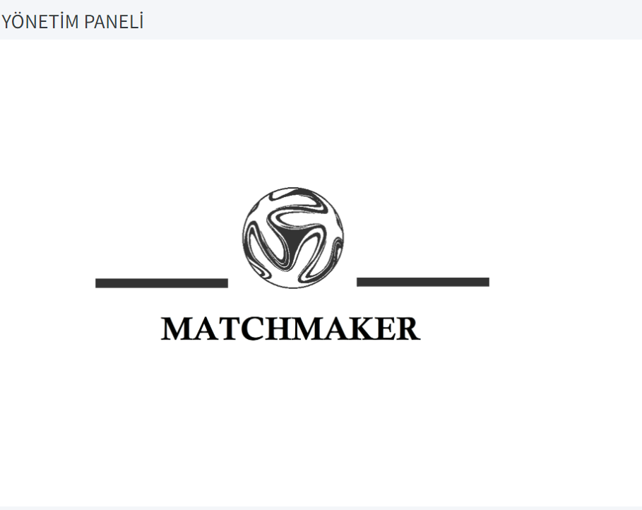

Figure 17.

Int. 3-1. PlayersList Page.

metin, iç mekan, ekran görüntüsü içeren bir resim

Açıklama otomatik olarak oluşturuldu

Figure 18.

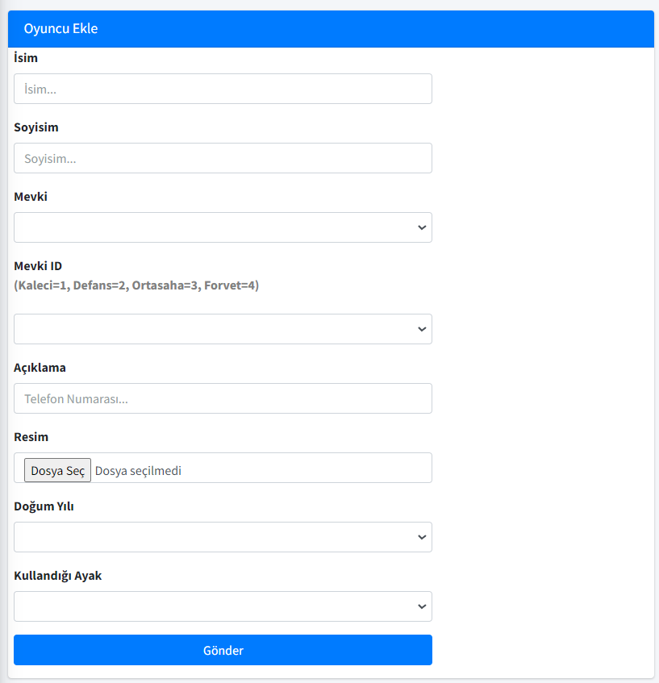Int. 3-2. Addplayers Page.

Figure 19.

Int. 3-3. Player-Edit Page.

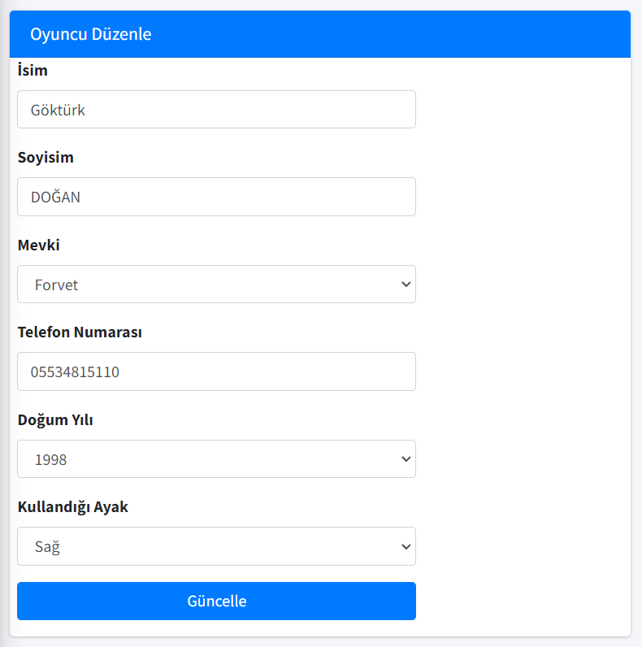

Figure 20.

Int. 4-1. Facilities-List Page.

metin içeren bir resim

Açıklama otomatik olarak oluşturuldu

Figure 21.

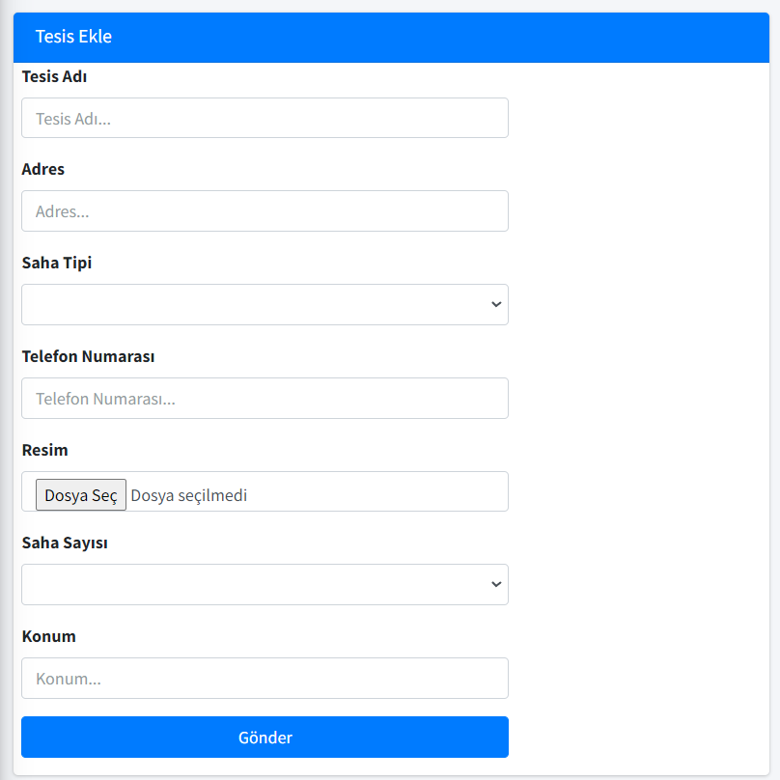Int. 4-2. Facilityadd Page.

Figure 22.

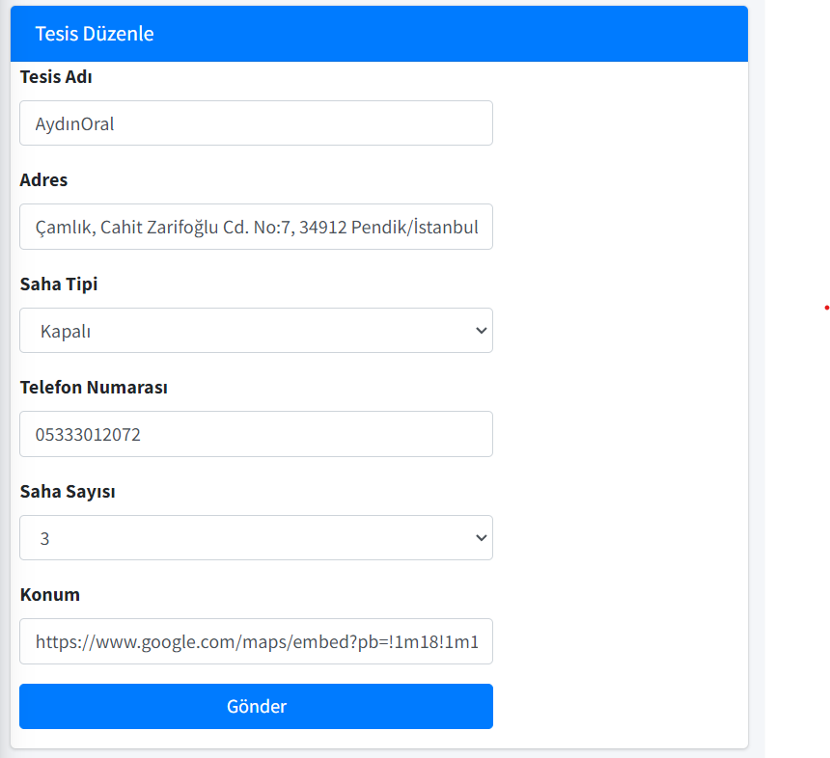Int. 4-3. Facility-edit Page.

Figure 23.

Int. 5-1. Matches-list Page.

metin, ekran görüntüsü, iç mekan içeren bir resim

Açıklama otomatik olarak oluşturuldu

Figure 24.

Int. 5-2. Addmatch Page.

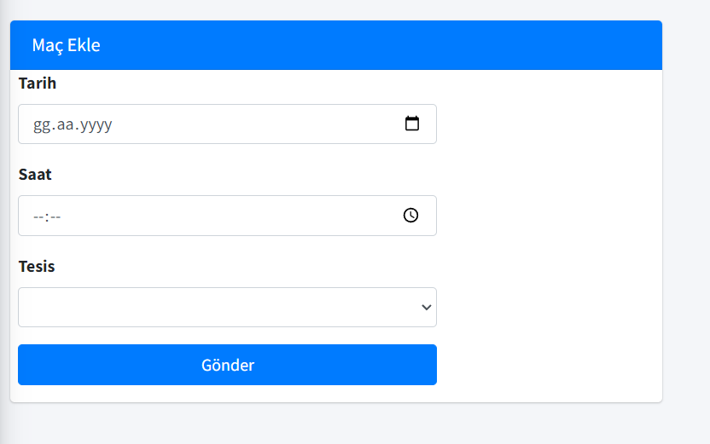

Figure 25.

Int. 5-3. Addteam Page.

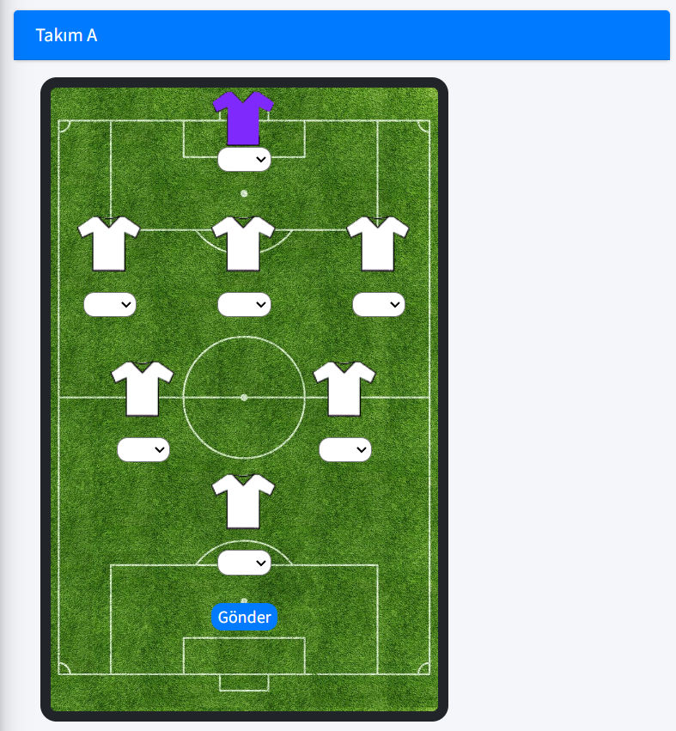

Figure 26.

Int. 5-4. Vote Page.

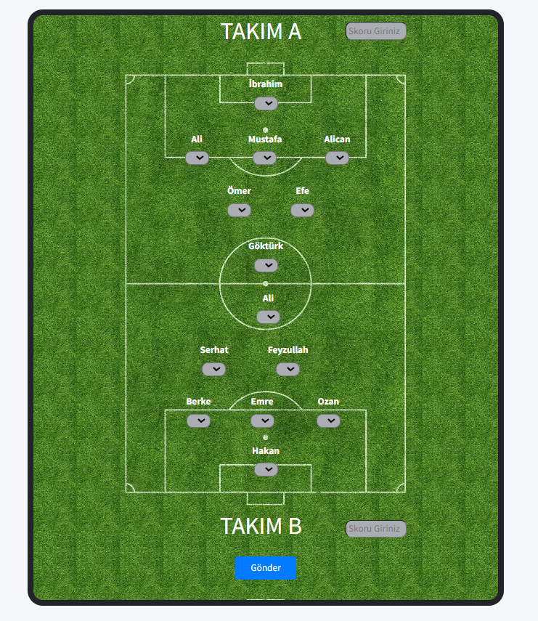

Figure 27.

metin içeren bir resim

Açıklama otomatik olarak oluşturulduInt. 6-1-1. Error.

Figure 28.

metin içeren bir resim

Açıklama otomatik olarak oluşturulduInt. 6-1-2. Error.

Figure 29.

metin içeren bir resim

Açıklama otomatik olarak oluşturulduInt. 6-1-3. Error.

Figure 30.

Int. 6-2-1. Success.

Figure 31.

metin, elektronik eşyalar, ekran görüntüsü içeren bir resim

Açıklama otomatik olarak oluşturulduInt. 7. Menu.

Figure 32.

**3.4.2 USER INTERFACE**

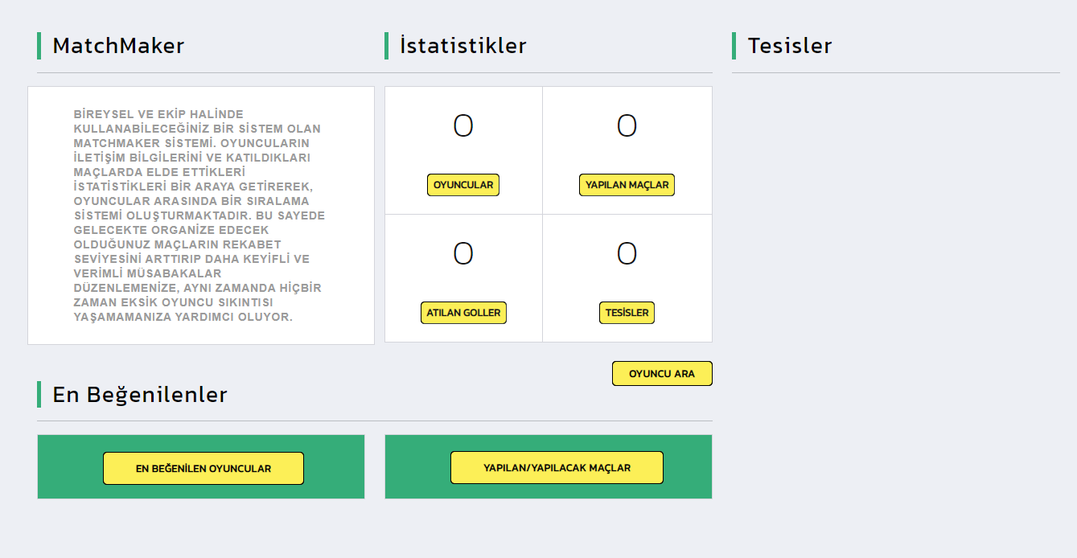Int. 8. HomePage.

Figure 33.

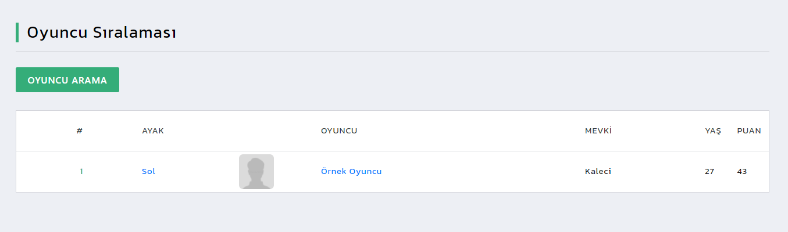Int. 9. Players Page.

Figure 34.

metin içeren bir resim

Açıklama otomatik olarak oluşturulduInt. 9-1. Player Detail Page.

Figure 35.

metin, ekran görüntüsü, iç mekan içeren bir resim

Açıklama otomatik olarak oluşturulduInt. 10-1 Facilities Page.

Figure 36.

metin içeren bir resim

Açıklama otomatik olarak oluşturulduInt. 10-2 Facility-Detail Page.

Figure 37.

Int. 11-1 Matches Page.

metin içeren bir resim

Açıklama otomatik olarak oluşturuldu

Figure 38.

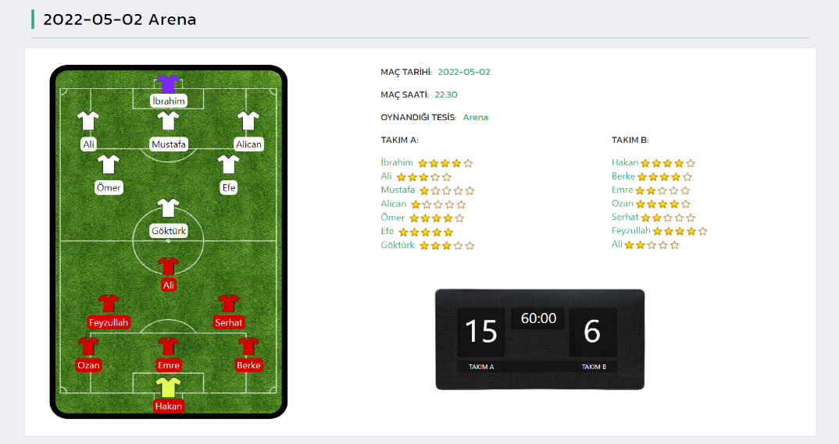Int. 11-2 Match-Detail Page.

Figure 39.

metin içeren bir resim

Açıklama otomatik olarak oluşturulduInt. 12 Menu.

Figure 40.

Int. 13 Footer.

metin, ekran görüntüsü, ekran içeren bir resim

Açıklama otomatik olarak oluşturuldu

Figure 41.

# 3.5. RECOMMENDATIONS

The project requires a PhpMyadmin database structure to be formed manually for the software.

Use of Php programming language may be beneficial for the ease of implementation.

**4. TEST PLAN AND TEST REPORT**

To test the matchmaker project, I included a few of the football organizations that I organized myself, which was the reason for the idea of ​​​​the project.

**4.1. ADDING PLAYERS**

First of all, I entered the information of the players who are likely to take part in the matches into the system.

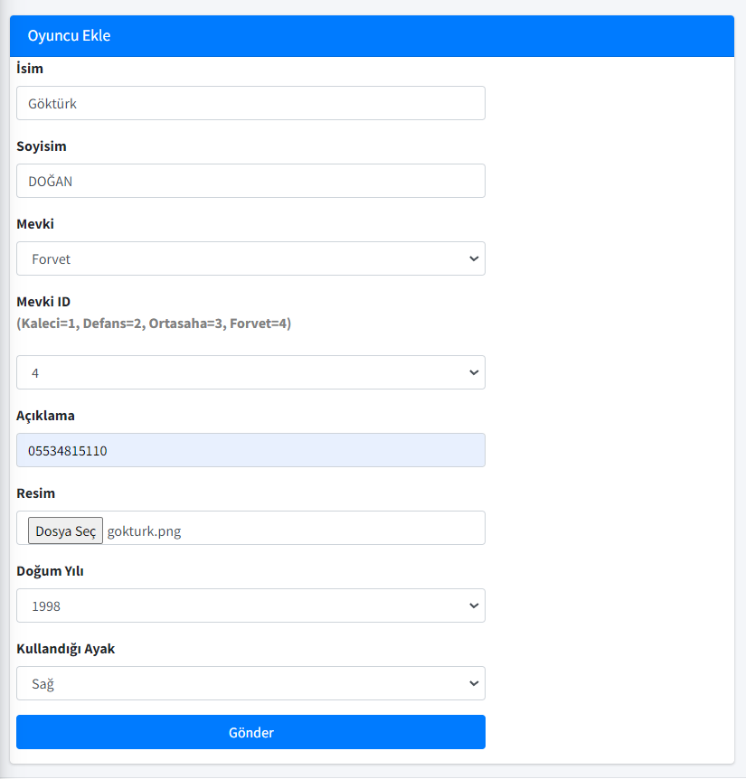

Figure 42.

I checked whether the players I added were successfully registered to the system and took a look at the pool of players.

metin, bilgisayar, iç mekan, beyaz içeren bir resim

Açıklama otomatik olarak oluşturuldu

Figure 43.

* 1. **ADDING FACILITY**

I checked whether the facilities that provide football services in nearby locations were entered into the system and added to the table.

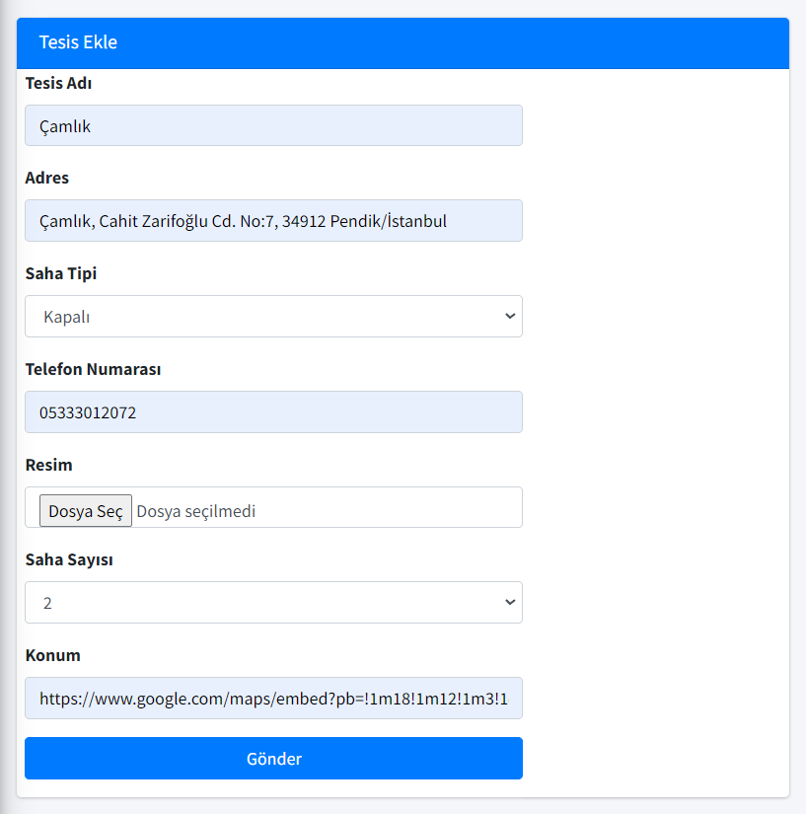

Figure 44.

metin içeren bir resim

Açıklama otomatik olarak oluşturuldu

Figure 45.

**4.3 ADDING MATCH**

I added a match to my site and created two separate teams from the players added to the pool.

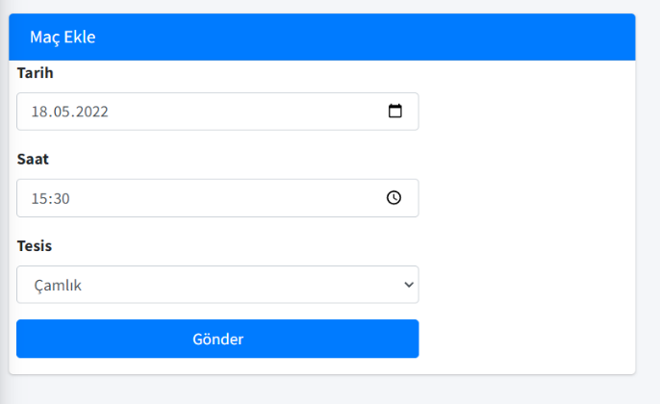

Figure 46.

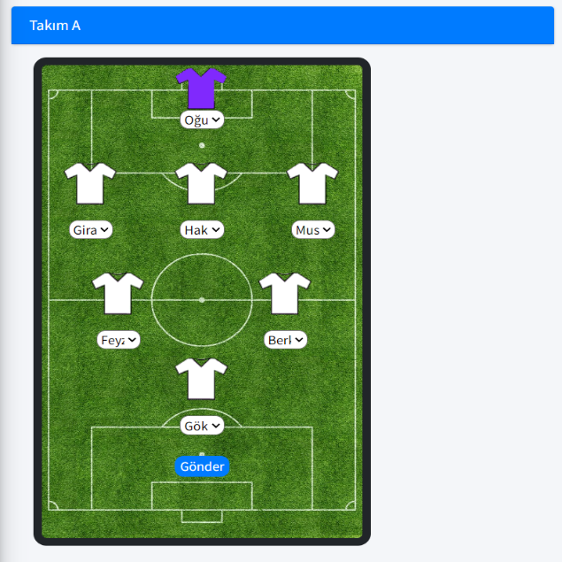

Figure 47.

After the match was completed, I made data entries from the management panel to give the scores of the players and to make the entries of the scores produced by the teams.

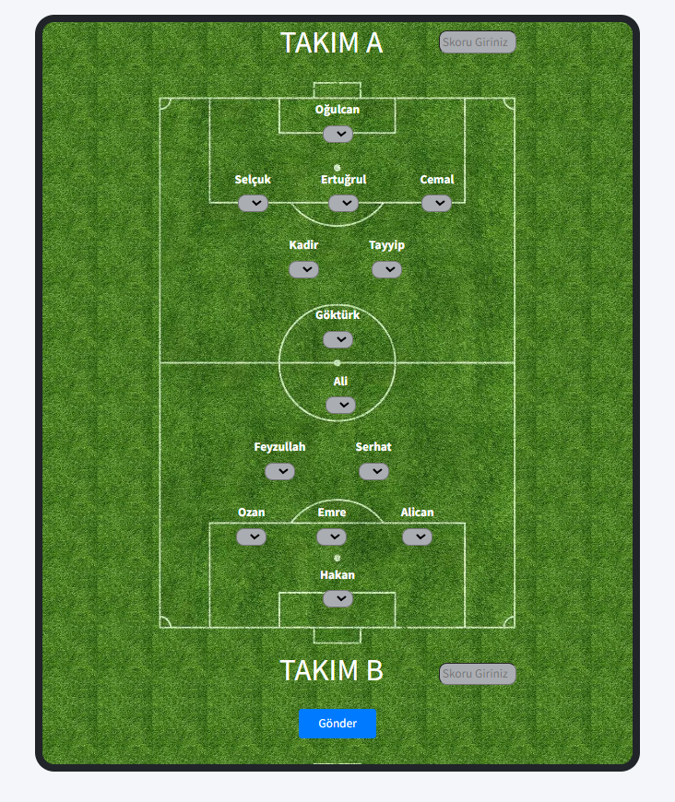

Figure 48.

Since all the features in the system work smoothly, no problems were encountered during the testing phases.

1. **DISCUSSION AND CONCLUSION**

**5.1 Successful Aspects**

The Matchmaker project has succeeded in solving two basic problems that were set out in line with the purpose of its development. A player pool has been created for the players and the matches have been selected by the administrator with the help of select inputs. Players are given a point by the manager after the matches are over.

**5.2 Seficiencies**

The most basic shortcoming of this project in my eyes is that the scores given to the players by the manager after the matches are not kept in an external table. This event brings out the following result, the scores of the players are not calculated in one place and recorded in their tables as the average score, so before adding players to the match, the manager can be content with searching for the player from the search button and looking at the points he has received in the past matches.

**5.3 Suggestions**

In order to make the project more useful, a membership opening panel can be added to the system, so that a new user profile can be created as anonymous user, member users other than administrative users. By taking advantage of the functions brought by this profile, a comment system can be added after the matches, in which the member users indicate their votes for the relevant match. Thanks to this system, the objectivity of the scores given by the administrator user to the players can be discussed and an interactive structure can be added to the system.

**SOURCE**

* [https://www.udemy.com/](https://www.udemy.com/home/my-courses/learning/?category_filter=archived)
* https://www.youtube.com/c/PhpT%C3%BCrkiye
* https://adminlte.io/
* https://bootstrapmade.com/

**CV**

metin içeren bir resim

Açıklama otomatik olarak oluşturuldu